
L. J. Institute of Computer Application
L. J. University

Master of Computer Application

3rd Semester

Project Name :-
CarZen: Car Selling, Buying, Service System

Submitted To:
Mrs. Dharmi Doshi

Submitted By:
Boghara Aayush M Roll No: E01 25004401110004
Chudasama Vishal B Roll No: E02 25004401110069
Sakariya Pinak B Roll No: E06 25004401110067

Introduction

1.1 Problem Definition
The existing process of buying, selling, and servicing cars is often dependent on manual searches, individual dealers, classified advertisements, and personal estimation of vehicle prices. Buyers may find it difficult to determine whether a car is fairly priced, while sellers may not know the appropriate resal value of their vehicle.
There is also a lack of an integrated platform that combines car buying, car selling, vehicle service information, and price prediction in a single system.
The proposed CarZen system aims to develop an integrated vehicle marketplace and management platform that allows users to list cars for sale, search and compare available cars, manage information, access service-related information, and estimate the expected price of a vehicle using a machine-learning-based prediction system.
The frontend will be developed using Flutter. The backend will be developed using Python and FastAPI, while MySQL will store user, vehicle, selling, reselling, service, and prediction-related information.

1.2 Objective of the New System
The main objective is to develop an integrated platform for car buying, selling, reselling, servicing, and -price prediction.
- Provide a platform for users to buy and sell new or used cars.
- Allow sellers to create and manage car listings.
- Allow buyers to search and filter cars according to their requirements.
- Provide detailed information about available vehicles.
- Support reselling by maintaining vehicle and ownership information.
- Provide information related to vehicle servicing and maintenance.
- Predict the estimated price of a car using machine learning.
- Store system data securely and consistently using MySQL.
- Provide REST APIs using FastAPI for communication with the Flutter frontend.
- Provide an admin module for managing users, cars, services, listings and system data.
- Reduce the difficulty of estimating the market value of used cars.
- Improve transparency between buyers and sellers.

1.3 Core Components
Component | Description
User Management | Registration, login, authentication, profile management and role-based access.
Car Management | Vehicle attributes, listings, search and filtering.
Car Selling Module | Create, update, delete and manage vehicle listings and selling status.
Car Buying/Search Module | Search, filter, compare and view available vehicles.
Reselling Module | Ownership chain, purchase information, listing and history.
Car Service Module | Service type, date, cost, center, maintenance details and service history.
Price Prediction Module | Estimate expected value from relevant vehicle characteristics and historical data.
Admin Module | Manage users, cars, listings, service information, prediction records and system data.
FastAPI Backend | RESTful APIs connecting Flutter, business logic, database and prediction services.
MySQL Database | Primary relational database for structured application data.

1.4 Project Profile
Attribute | Specification
Project Name | CarZen — Car Selling, Reselling, Service and Price Prediction System
Project Type | Cross-platform application / marketplace platform
Domain | Automobile / E-Commerce / Machine Learning
Frontend | Flutter
Backend Language | Python
Backend Framework | FastAPI
Database | MySQL
API Architecture | REST API
Prediction | Machine Learning
Main Users | Buyers, Sellers, Car Owners, Service Providers and Administrator
Main Purpose | Car buying, selling, reselling, service management and -price prediction

1.5 Need of the New System
- Difficulty in determining the correct car price: users may not know the market value of a used vehicle.
- Lack of centralized information: car information, selling information and service records may be distributed across different sources.
- Manual price estimation: prices are often estimated from personal experience rather than a consistent data-driven method.
- Difficulty in finding suitable cars: buyers need efficient search and filtering.
- Limited vehicle history information: previous ownership and service information may not be easily available.
- Lack of integrated service management: service information is often maintained separately.
- Need for an organized used-car workflow: buying and reselling activities benefit from a centralized platform.
- Need for data-driven prediction: machine learning can estimate price from historical and current vehicle attributes.

1.6 Scope of the New System
Scope Area | Included Functions
Buyer Scope | Registration/login; search; filtering; comparison; vehicle details; expected price; seller information; service information.
Seller Scope | Seller registration; car listing; vehicle information/images; asking price; update/remove listing; selling status.
Reselling Scope | Add vehicle; ownership information; previous purchase details; -price estimate; listing; history.
Service Scope | Add service records; view service history; service dates; service costs; maintenance information.
Prediction Scope | Use historical/current vehicle attributes to estimate expected price.
Admin Scope | Manage users, vehicles, listings, service records, prediction data, reported content and system activity.

Advantages and Limitations of the Proposed System

Advantages
- Provides a single platform for car buying, selling and reselling.
- Makes it easier to search and filter vehicles.
- Helps users estimate the value of a car.
- Maintains vehicle, ownership and service information.
- Provides secure and structured data management using MySQL.
- Helps buyers and sellers make better pricing and purchasing decisions.

Limitations
- Prediction accuracy depends on the quality of available data.
- Predicted price may differ from the actual market price.
- Incorrect vehicle information can affect the prediction result.
- The system requires a reliable internet connection.
- Service and prediction features may have limited coverage during the initial implementation.

1.8 Proposed Time Line Chart
Phase | Activities | Duration | Progress
Phase 1 | Requirement Analysis | Week 1 | ✓
Phase 2 | System Analysis and Planning | Week 2 | ✓
Phase 3 | Database Design using MySQL | Week 3 | ✓
Phase 4 | System and API Design | Week 4 | ✓
Phase 5 | User and Authentication Module | Week 5 | ✓
Phase 6 | Car Buying Module | Week 6 | ✓
Phase 7 | Car Selling Module | Week 7
Phase 8 | Car Service Module | Week 8
Phase 9 | Dataset Preparation and ML Model | Week 9
Phase 10 | Price Prediction Integration | Week 10
Phase 11 | Testing and Bug Fixing | Week 11
Phase 12 | Final Documentation and Deployment | Week 12

1.9 Targeted Users
User Type | Main Purpose / Responsibilities
Buyers | Search for and purchase new or used cars; view details, service information and predicted value.
Sellers | List vehicles, set prices, update listings and manage selling status.
Car Owners | Maintain vehicle/service information and determine expected value.
Service Providers | Add and update vehicle maintenance records and service history.
Administrator | Manage users, vehicles, listings, services, prediction records and overall system operations.

2. Requirement Determination and Analysis

2.1 Requirement Determination
Requirement determination identifies the main requirements needed to develop and operate the Caren – Car Selling, Buying, Service & Price Prediction System.
The major requirements are:
Functional Requirements
- User registration and login.
- User profile management and authentication.
- Add, update and delete car information.
- Create and manage car listings.
- Search and filter available cars.
- View detailed vehicle information.
- Manage favourites and inquiries.
- Maintain ownership and information.
- Maintain vehicle service records.
- Predict estimated price using Machine Learning.
- Admin management of users, cars and listings.
Non-Functional Requirements
- Security: Secure authentication and authorization.
- Performance: Fast response to user requests.
- Reliability: Maintain consistent and accurate data.
- Scalability: Support increasing users and vehicle records.
- Usability: Simple and user-friendly interface.
- Maintainability: Modular and easily maintainable backend.
Technical Requirements
- Frontend: Flutter
- Backend: Python + Fast API
- Database: MySQL
- API: REST API
- Machine Learning: Python ML libraries
- Testing: Postman
- Version Control: Git/GitHub

2.2 Requirement Specification
The following specifications define what the Caren system should provide.
Module | Requirement
User Management | Register, login and manage user profile.
Car Management | Add, update, delete and view vehicle information.
Listing Management | Create, update and manage car sale/ listings.
Search | Search and filter cars according to requirements.
Ownership | Maintain vehicle ownership and transaction history.
Service | Store and view vehicle service and maintenance records.
Price Prediction | Accept vehicle details and provide estimated price.
Favorites | Allow users to save preferred vehicles.
Inquiry | Maintain buyer-seller communication/inquiry information.
Admin | Manage users, cars, listings and system data.

Database Requirements
The system requires a relational MySQL database to store:
Users, Addresses, Cars, Car Brands, Car Models, Car Variants, Listings, Ownership History, Service Records, Favourites, Inquiries, Transactions and Price Predictions.

Machine Learning Requirements
The prediction module will use vehicle information such as brand, model, manufacturing year, mileage, fuel type, transmission, engine capacity, number of owners, condition and location to estimate the price.

3. System Design

3.1 Use Case Diagram
The Use Case Diagram represents the interaction between users and the Car Service & Used Car Web Paortal. It shows the major functions available to different types of users. The Customer can register, log in, manage their profile, book car services, view booking status, and cancel bookings. The Seller can register, manage their profile, list used cars, manage listings, and remove listings. The diagrams also show the activities required for service booking and used-car listing.
Admin Diagram
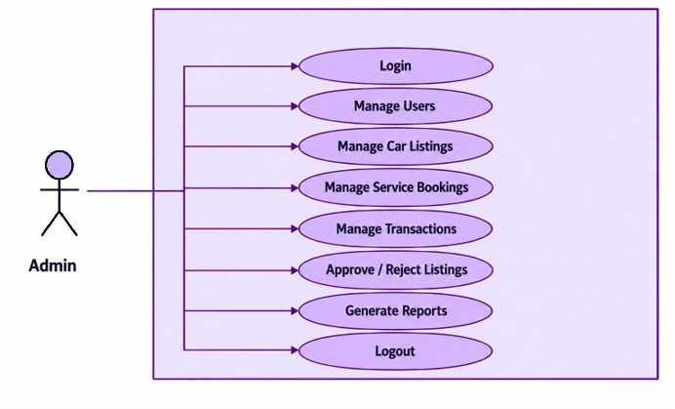

Seller Diagram
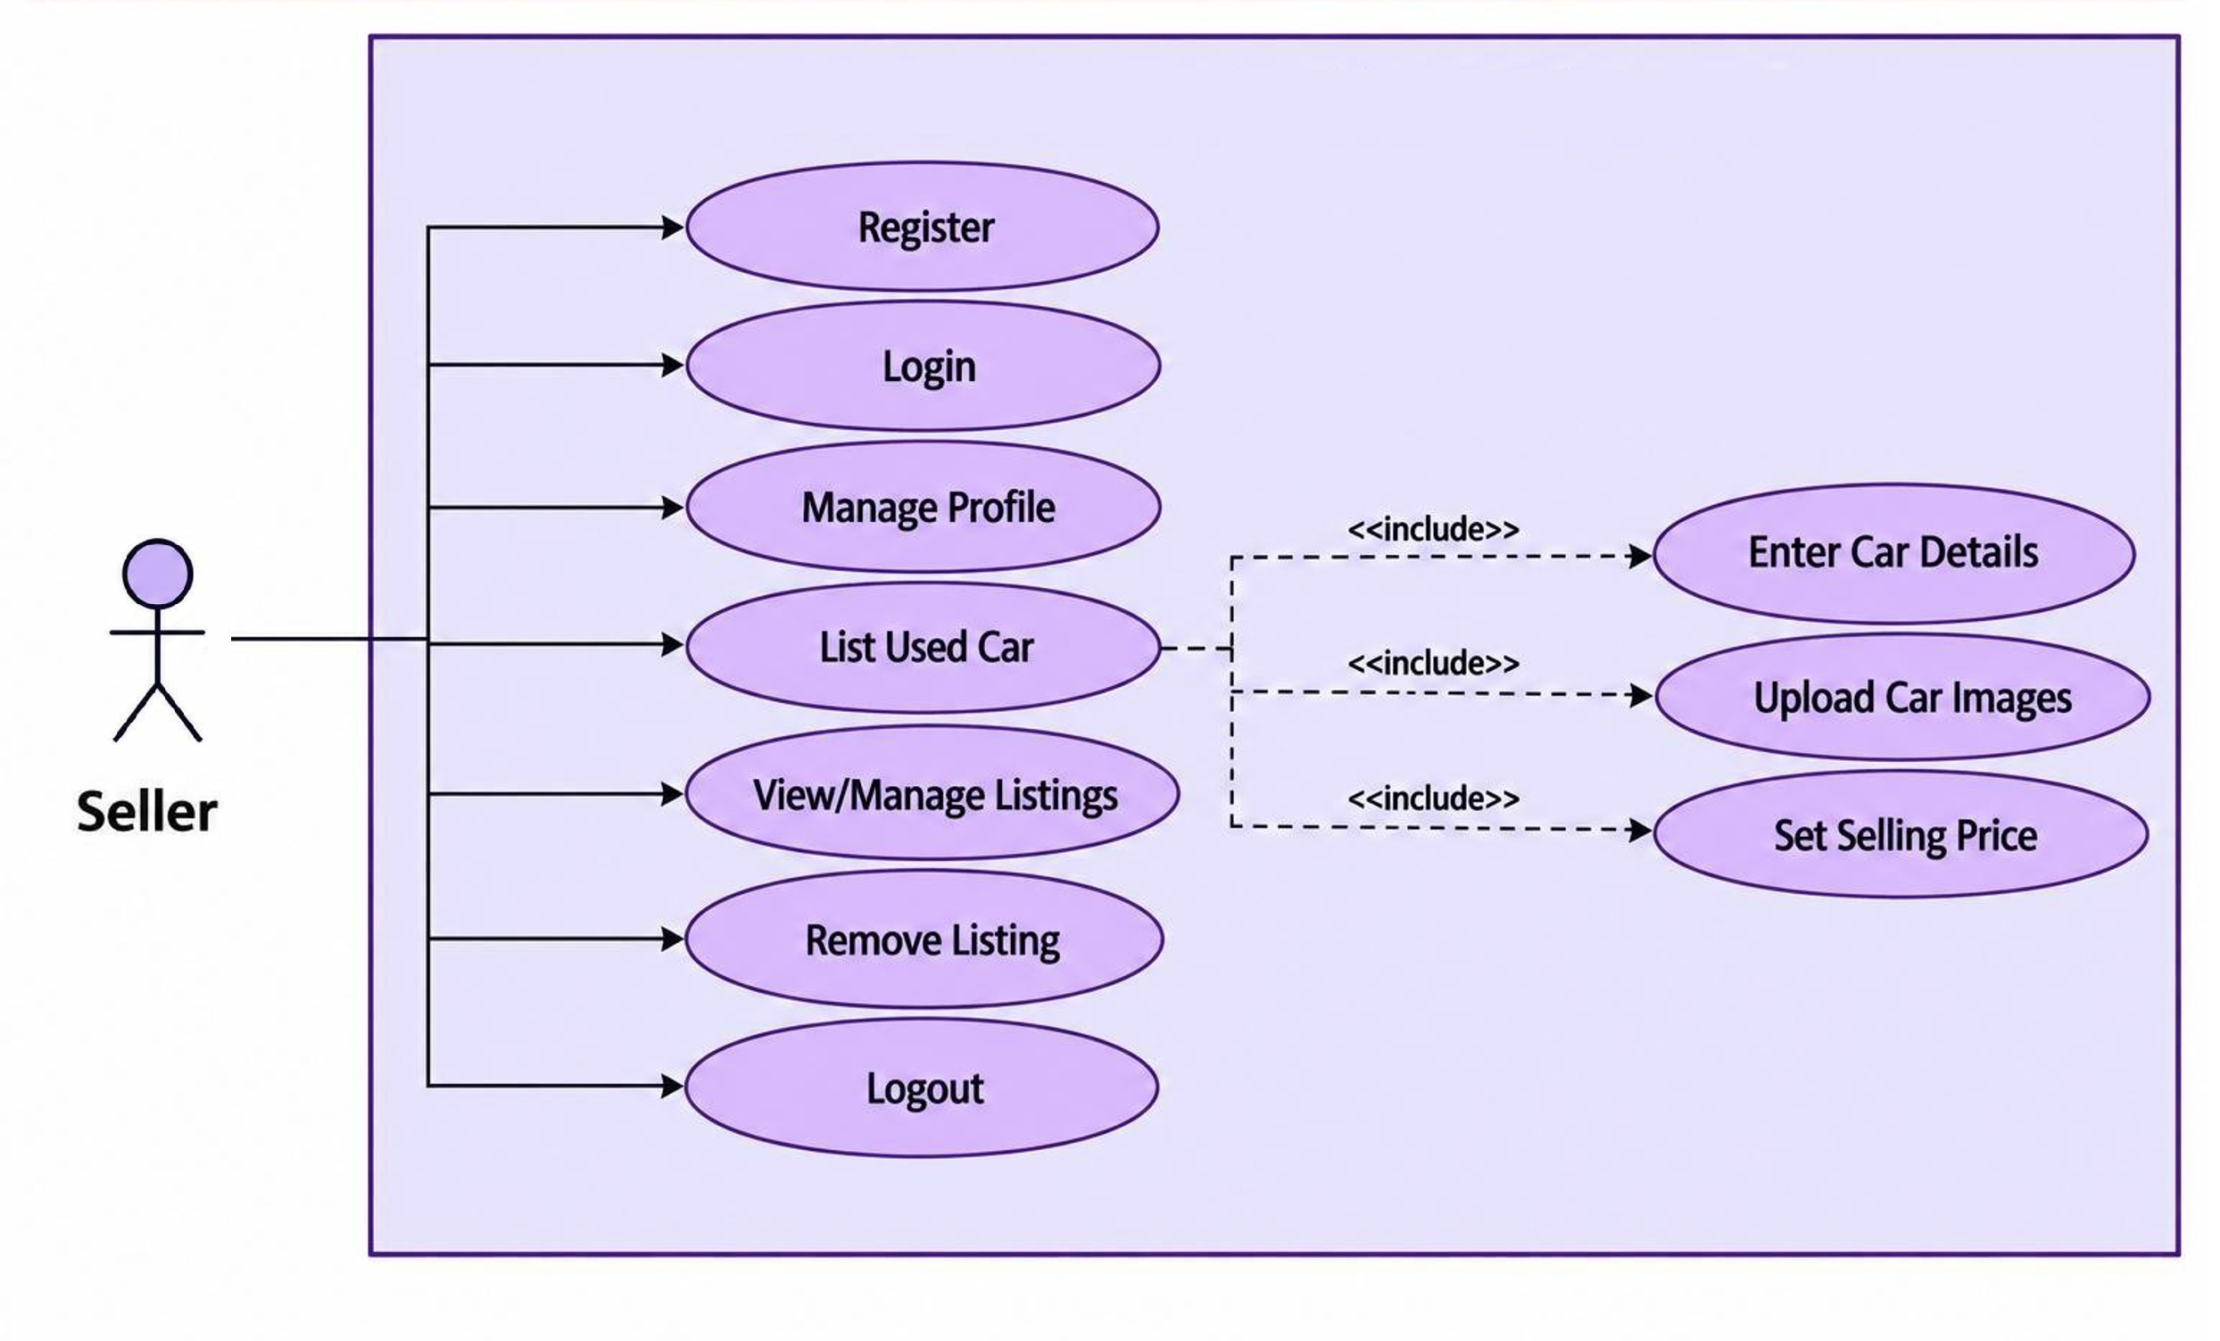
Customer (User) Diagram
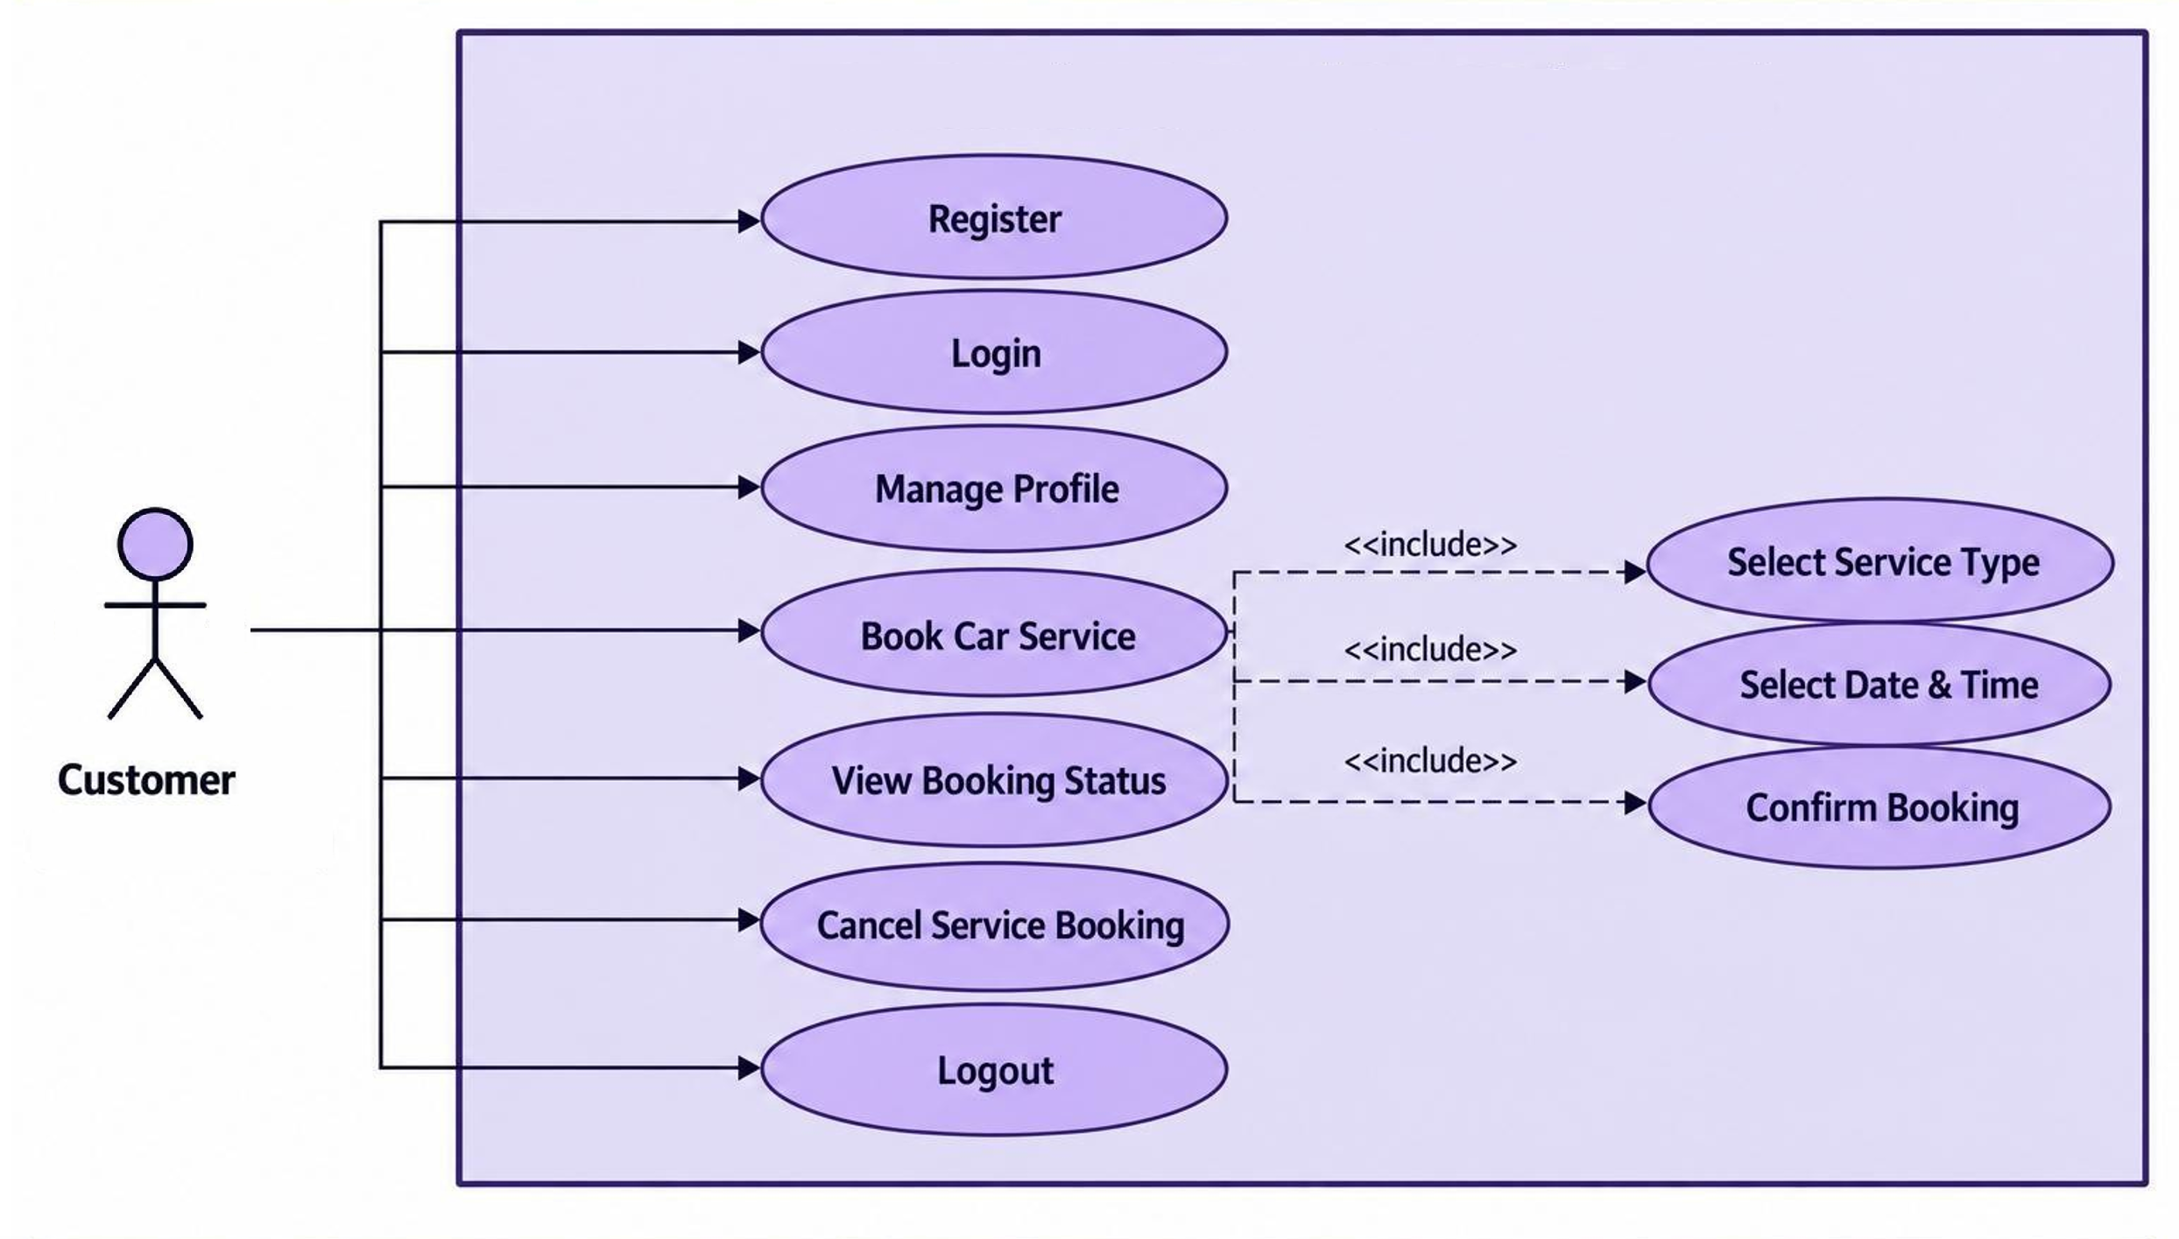

3.2 Data Dictionary
The Data Dictionary describes the database structure of the Car Service & Used Car Web Portal. It lists each database table, its fields, data types, key information, nullability, default values, and the purpose of each field. The dictionary is prepared directly from the provided SQL database schema

users
Field Name | Data Type | Nullable | Default | Key | Description
id | bigint | No | — | Primary Key | Unique identifier.
first_name | varchar(100) | No | — | — | First name of the user.
last_name | varchar(100) | Yes | — | — | Last name of the user.
username | varchar(100) | No | — | — | Unique username of the user.
email | varchar(150) | No | — | — | Unique email address.
password_hash | varchar(255) | No | — | — | Hashed password value.
phone_number | varchar(20) | Yes | — | — | User or service-center contact number.
role | ENUM | No | — | — | Role assigned to the user or administrator.
status | ENUM | Yes | — | — | Current status of the record.
profile_image_url | varchar(500) | Yes | — | — | URL of the profile image.
created_at | timestamp | Yes | — | — | Date and time when the record was created.
updated_at | timestamp | Yes | — | — | Date and time when the record was last updated.
deleted_at | timestamp | Yes | — | — | Date and time associated with deletion.

car_brands
Field Name | Data Type | Nullable | Default | Key | Description
id | bigint | No | — | Primary Key | Unique identifier.
name | varchar(100) | No | — | — | Name of the brand, model, or service center.
slug | varchar(120) | No | — | — | Unique URL-friendly identifier.
country | varchar(100) | Yes | — | — | Country.
logo_url | varchar(500) | Yes | — | — | URL of the brand logo.
description | text | Yes | — | — | Description or additional details.
is_active | boolean | Yes | — | — | Indicates whether the administrator account is active.
created_at | timestamp | Yes | — | — | Date and time when the record was created.
updated_at | timestamp | Yes | — | — | Date and time when the record was last updated.
deleted_at | timestamp | Yes | — | — | Date and time associated with deletion.

car_models
Field Name | Data Type | Nullable | Default | Key | Description
id | bigint | No | — | Primary Key | Unique identifier.
brand_id | bigint | No | — | Foreign Key | Identifier of the related car brand.
name | varchar(100) | No | — | — | Name of the brand, model, or service center.
slug | varchar(120) | No | — | — | Unique URL-friendly identifier.
body_type | ENUM | Yes | — | — | Body type of the car model.
seating_capacity | integer | Yes | — | — | Number of seats.
description | text | Yes | — | — | Description or additional details.
is_active | boolean | Yes | — | — | Indicates whether the administrator account is active.
created_at | timestamp | Yes | — | — | Date and time when the record was created.
updated_at | timestamp | Yes | — | — | Date and time when the record was last updated.
deleted_at | timestamp | Yes | — | — | Date and time associated with deletion.

car_variants
Field Name | Data Type | Nullable | Default | Key | Description
id | bigint | No | — | Primary Key | Unique identifier.
model_id | bigint | No | — | Foreign Key | Identifier of the related car model.
variant_name | varchar(150) | No | — | — | Name of the car variant.
fuel_type | ENUM | No | — | — | Fuel type of the vehicle.
transmission | ENUM | No | — | — | Transmission type of the vehicle.
engine_cc | decimal(8,2) | Yes | — | — | Engine capacity in cubic centimetres.
horsepower | decimal(8,2) | Yes | — | — | Engine power in horsepower.
seating_capacity | integer | Yes | — | — | Number of seats.
ex_showroom_price | decimal(15,2) | Yes | — | — | Ex-showroom price of the variant.
created_at | timestamp | Yes | — | — | Date and time when the record was created.
updated_at | timestamp | Yes | — | — | Date and time when the record was last updated.
deleted_at | timestamp | Yes | — | — | Date and time associated with deletion.

cars
Field Name | Data Type | Nullable | Default | Key | Description
id | bigint | No | — | Primary Key | Unique identifier.
variant_id | bigint | No | — | Foreign Key | Identifier of the related car variant.
owner_id | bigint | No | — | Foreign Key | Identifier of the vehicle owner.
registration_number | varchar(30) | Yes | — | — | Vehicle registration number.
vin_number | varchar(100) | Yes | — | — | Vehicle identification number (VIN).
manufacturing_year | integer | No | — | — | Year in which the vehicle was manufactured.
registration_year | integer | Yes | — | — | Year in which the vehicle was registered.
fuel_type | ENUM | No | — | — | Fuel type of the vehicle.
transmission | ENUM | No | — | — | Transmission type of the vehicle.
engine_cc | decimal(8,2) | Yes | — | — | Engine capacity in cubic centimetres.
horsepower | decimal(8,2) | Yes | — | — | Engine power in horsepower.
mileage_km | decimal(12,2) | No | — | — | Vehicle mileage in kilometres.
color | varchar(50) | Yes | — | — | Vehicle colour.
seating_capacity | integer | Yes | — | — | Number of seats.
owner_count | integer | Yes | — | — | Number of owners.
ownership_type | ENUM | Yes | — | — | Ownership sequence/type.
condition | ENUM | No | — | — | Current condition of the vehicle.
insurance_company | varchar(150) | Yes | — | — | Name of the insurance company.
insurance_type | varchar(100) | Yes | — | — | Type of insurance.
insurance_expiry | date | Yes | — | — | Insurance expiry date.
rc_status | varchar(50) | Yes | — | — | Registration Certificate status.
city | varchar(100) | No | — | — | City.
state | varchar(100) | No | — | — | State or region.
country | varchar(100) | Yes | — | — | Country.
postal_code | varchar(10) | Yes | — | — | Postal/PIN code.
description | text | Yes | — | — | Description or additional details.
expected_market_price | decimal(15,2) | Yes | — | — | Data field used by the system.
is_verified | boolean | Yes | — | — | Indicates whether the record is verified.
created_at | timestamp | Yes | — | — | Date and time when the record was created.
updated_at | timestamp | Yes | — | — | Date and time when the record was last updated.
deleted_at | timestamp | Yes | — | — | Date and time associated with deletion.

car_media
Field Name | Data Type | Nullable | Default | Key | Description
id | bigint | No | — | Primary Key | Unique identifier.
car_id | bigint | No | — | Foreign Key | Identifier of the related car.
media_type | ENUM | No | — | — | Type of media associated with the car.
media_url | varchar(500) | No | — | — | URL of the media file.
thumbnail_url | varchar(500) | Yes | — | — | URL of the media thumbnail.
file_name | varchar(255) | Yes | — | — | Name of the uploaded file.
file_size | bigint | Yes | — | — | Size of the uploaded file.
sort_order | integer | Yes | — | — | Display order of the media item.
is_primary | boolean | Yes | — | — | Indicates whether the media item is primary.
created_at | timestamp | Yes | — | — | Date and time when the record was created.
deleted_at | timestamp | Yes | — | — | Date and time associated with deletion.

listings
Field Name | Data Type | Nullable | Default | Key | Description
id | bigint | No | — | Primary Key | Unique identifier.
car_id | bigint | No | — | Foreign Key | Identifier of the related car.
seller_id | bigint | No | — | Foreign Key | Identifier of the seller.
listing_type | ENUM | No | — | — | Type of listing.
title | varchar(255) | No | — | — | Title of the listing.
description | text | Yes | — | — | Description or additional details.
asking_price | decimal(15,2) | No | — | — | Price requested for the listing.
negotiable | boolean | Yes | — | — | Indicates whether the asking price is negotiable.
listing_status | ENUM | Yes | — | — | Current status of the listing.
listed_at | timestamp | Yes | — | — | Date and time when the listing was listed.
expiry_date | timestamp | Yes | — | — | Date and time when the listing expires.
views_count | integer | Yes | — | — | Number of listing views.
created_at | timestamp | Yes | — | — | Date and time when the record was created.
updated_at | timestamp | Yes | — | — | Date and time when the record was last updated.
deleted_at | timestamp | Yes | — | — | Date and time associated with deletion.

ownership_history
Field Name | Data Type | Nullable | Default | Key | Description
id | bigint | No | — | Primary Key | Unique identifier.
car_id | bigint | No | — | Foreign Key | Identifier of the related car.
owner_id | bigint | No | — | Foreign Key | Identifier of the vehicle owner.
ownership_number | integer | No | — | — | Sequential ownership number.
ownership_type | ENUM | Yes | — | — | Ownership sequence/type.
purchase_date | date | Yes | — | — | Date of purchase.
sale_date | date | Yes | — | — | Date of sale.
purchase_price | decimal(15,2) | Yes | — | — | Purchase price.
sale_price | decimal(15,2) | Yes | — | — | Sale price.
purchase_location | varchar(150) | Yes | — | — | Location of purchase.
sale_location | varchar(150) | Yes | — | — | Location of sale.
created_at | timestamp | Yes | — | — | Date and time when the record was created.

service_centers
Field Name | Data Type | Nullable | Default | Key | Description
id | bigint | No | — | Primary Key | Unique identifier.
owner_id | bigint | Yes | — | Foreign Key | Identifier of the vehicle owner.
name | varchar(200) | No | — | — | Name of the brand, model, or service center.
contact_person | varchar(150) | Yes | — | — | Contact person at the service center.
email | varchar(150) | Yes | — | — | Unique email address.
phone_number | varchar(20) | Yes | — | — | User or service-center contact number.
address_line_1 | varchar(255) | Yes | — | — | Primary address line.
address_line_2 | varchar(255) | Yes | — | — | Additional address line.
city | varchar(100) | Yes | — | — | City.
state | varchar(100) | Yes | — | — | State or region.
country | varchar(100) | Yes | — | — | Country.
postal_code | varchar(10) | Yes | — | — | Postal/PIN code.
latitude | decimal(10,7) | Yes | — | — | Geographical latitude.
longitude | decimal(10,7) | Yes | — | — | Geographical longitude.
rating | decimal(3,2) | Yes | — | — | Rating value.
is_verified | boolean | Yes | — | — | Indicates whether the record is verified.
is_active | boolean | Yes | — | — | Indicates whether the administrator account is active.
created_at | timestamp | Yes | — | — | Date and time when the record was created.
updated_at | timestamp | Yes | — | — | Date and time when the record was last updated.
deleted_at | timestamp | Yes | — | — | Date and time associated with deletion.

service_records
Field Name | Data Type | Nullable | Default | Key | Description
id | bigint | No | — | Primary Key | Unique identifier.
car_id | bigint | No | — | Foreign Key | Identifier of the related car.
service_center_id | bigint | Yes | — | Foreign Key | Identifier of the related service center.
service_type | varchar(150) | No | — | — | Type of service performed.
service_date | date | No | — | — | Date of service.
odometer_reading | decimal(12,2) | Yes | — | — | Odometer reading at service time.
service_cost | decimal(15,2) | Yes | — | — | Total service cost.
parts_cost | decimal(15,2) | Yes | — | — | Cost of parts.
labor_cost | decimal(15,2) | Yes | — | — | Labour cost.
description | text | Yes | — | — | Description or additional details.
next_service_date | date | Yes | — | — | Recommended next service date.
next_service_mileage | decimal(12,2) | Yes | — | — | Recommended next service mileage.
status | ENUM | Yes | — | — | Current status of the record.
created_at | timestamp | Yes | — | — | Date and time when the record was created.
updated_at | timestamp | Yes | — | — | Date and time when the record was last updated.

service_items
Field Name | Data Type | Nullable | Default | Key | Description
id | bigint | No | — | Primary Key | Unique identifier.
service_record_id | bigint | No | — | Foreign Key | Identifier of the related service record.
item_name | varchar(150) | No | — | — | Name of the service item.
quantity | integer | Yes | — | — | Quantity of the service item.
unit_cost | decimal(15,2) | Yes | — | — | Cost per unit.
total_cost | decimal(15,2) | Yes | — | — | Total cost for the service item.
created_at | timestamp | Yes | — | — | Date and time when the record was created.

favorites
Field Name | Data Type | Nullable | Default | Key | Description
id | bigint | No | — | Primary Key | Unique identifier.
user_id | bigint | No | — | Foreign Key | Identifier of the related user.
car_id | bigint | No | — | Foreign Key | Identifier of the related car.
created_at | timestamp | Yes | — | — | Date and time when the record was created.

inquiries
Field Name | Data Type | Nullable | Default | Key | Description
id | bigint | No | — | Primary Key | Unique identifier.
listing_id | bigint | No | — | Foreign Key | Identifier of the related listing.
buyer_id | bigint | No | — | Foreign Key | Identifier of the buyer.
seller_id | bigint | No | — | Foreign Key | Identifier of the seller.
subject | varchar(255) | Yes | — | — | Subject of the inquiry.
message | text | No | — | — | Inquiry or notification message.
status | ENUM | Yes | — | — | Current status of the record.
created_at | timestamp | Yes | — | — | Date and time when the record was created.
updated_at | timestamp | Yes | — | — | Date and time when the record was last updated.

transactions
Field Name | Data Type | Nullable | Default | Key | Description
id | bigint | No | — | Primary Key | Unique identifier.
listing_id | bigint | No | — | Foreign Key | Identifier of the related listing.
car_id | bigint | No | — | Foreign Key | Identifier of the related car.
buyer_id | bigint | No | — | Foreign Key | Identifier of the buyer.
seller_id | bigint | No | — | Foreign Key | Identifier of the seller.
final_price | decimal(15,2) | No | — | — | Final transaction price.
transaction_date | timestamp | Yes | — | — | Date and time of the transaction.
payment_method | ENUM | Yes | — | — | Method used for payment.
payment_status | ENUM | Yes | — | — | Current payment status.
transaction_status | ENUM | Yes | — | — | Current transaction status.
notes | text | Yes | — | — | Additional transaction notes.
created_at | timestamp | Yes | — | — | Date and time when the record was created.
updated_at | timestamp | Yes | — | — | Date and time when the record was last updated.

payments
Field Name | Data Type | Nullable | Default | Key | Description
id | bigint | No | — | Primary Key | Unique identifier.
transaction_id | bigint | No | — | Foreign Key | Identifier of the related transaction.
amount | decimal(15,2) | No | — | — | Payment amount.
currency | varchar(10) | Yes | — | — | Currency used for the payment.
payment_method | ENUM | Yes | — | — | Method used for payment.
provider | varchar(100) | Yes | — | — | Payment provider.
provider_transaction_id | varchar(255) | Yes | — | Foreign Key | Transaction identifier supplied by the payment provider.
status | ENUM | Yes | — | — | Current status of the record.
payment_date | timestamp | Yes | — | — | Date and time of payment.
metadata | json | Yes | — | — | Additional payment metadata in JSON format.
created_at | timestamp | Yes | — | — | Date and time when the record was created.
updated_at | timestamp | Yes | — | — | Date and time when the record was last updated.

price_predictions
Field Name | Data Type | Nullable | Default | Key | Description
id | bigint | No | — | Primary Key | Unique identifier.
car_id | bigint | Yes | — | Foreign Key | Identifier of the related car.
user_id | bigint | No | — | Foreign Key | Identifier of the related user.
prediction_status | ENUM | Yes | — | — | Current status of the price prediction.
predicted_price | decimal(15,2) | Yes | — | — | Predicted vehicle price.
minimum_price | decimal(15,2) | Yes | — | — | Minimum predicted price.
maximum_price | decimal(15,2) | Yes | — | — | Maximum predicted price.
confidence_score | decimal(5,2) | Yes | — | — | Confidence score of the prediction.
model_name | varchar(150) | Yes | — | — | Name of the prediction model.
model_version | varchar(100) | Yes | — | — | Version of the prediction model.
prediction_input | json | Yes | — | — | Input data used for the prediction in JSON format.
prediction_date | timestamp | Yes | — | — | Date and time of the prediction.
created_at | timestamp | Yes | — | — | Date and time when the record was created.

prediction_features
Field Name | Data Type | Nullable | Default | Key | Description
id | bigint | No | — | Primary Key | Unique identifier.
prediction_id | bigint | No | — | Foreign Key | Identifier of the related price prediction.
feature_name | varchar(100) | No | — | — | Name of a car feature.
feature_value | varchar(255) | Yes | — | — | Value of a prediction feature.
created_at | timestamp | Yes | — | — | Date and time when the record was created.

reviews
Field Name | Data Type | Nullable | Default | Key | Description
id | bigint | No | — | Primary Key | Unique identifier.
user_id | bigint | No | — | Foreign Key | Identifier of the related user.
car_id | bigint | Yes | — | Foreign Key | Identifier of the related car.
listing_id | bigint | Yes | — | Foreign Key | Identifier of the related listing.
rating | integer | No | — | — | Rating value.
title | varchar(255) | Yes | — | — | Title of the listing.
review_text | text | Yes | — | — | Review content.
is_visible | boolean | Yes | — | — | Indicates whether the review is visible.
created_at | timestamp | Yes | — | — | Date and time when the record was created.
updated_at | timestamp | Yes | — | — | Date and time when the record was last updated.
deleted_at | timestamp | Yes | — | — | Date and time associated with deletion.

reports
Field Name | Data Type | Nullable | Default | Key | Description
id | bigint | No | — | Primary Key | Unique identifier.
reporter_id | bigint | No | — | Foreign Key | Identifier of the user who submitted the report.
listing_id | bigint | Yes | — | Foreign Key | Identifier of the related listing.
car_id | bigint | Yes | — | Foreign Key | Identifier of the related car.
reason | varchar(255) | No | — | — | Reason for submitting the report.
description | text | Yes | — | — | Description or additional details.
status | varchar(50) | Yes | — | — | Current status of the record.
created_at | timestamp | Yes | — | — | Date and time when the record was created.
resolved_at | timestamp | Yes | — | — | Date and time when the report was resolved.

notifications
Field Name | Data Type | Nullable | Default | Key | Description
id | bigint | No | — | Primary Key | Unique identifier.
user_id | bigint | No | — | Foreign Key | Identifier of the related user.
title | varchar(255) | No | — | — | Title of the listing.
message | text | No | — | — | Inquiry or notification message.
notification_type | varchar(100) | Yes | — | — | Type of notification.
reference_id | bigint | Yes | — | Foreign Key | Identifier of the referenced record.
reference_type | varchar(100) | Yes | — | — | Type of record referenced by the notification.
is_read | boolean | Yes | — | — | Indicates whether the notification has been read.
created_at | timestamp | Yes | — | — | Date and time when the record was created.

3.3 User Interface Design
Login Page:
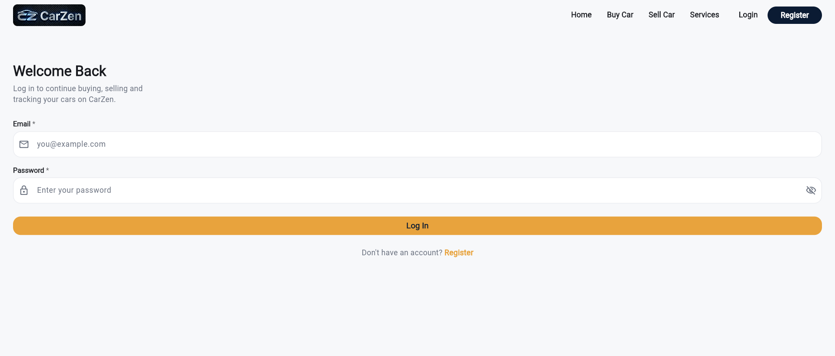

Register Page:
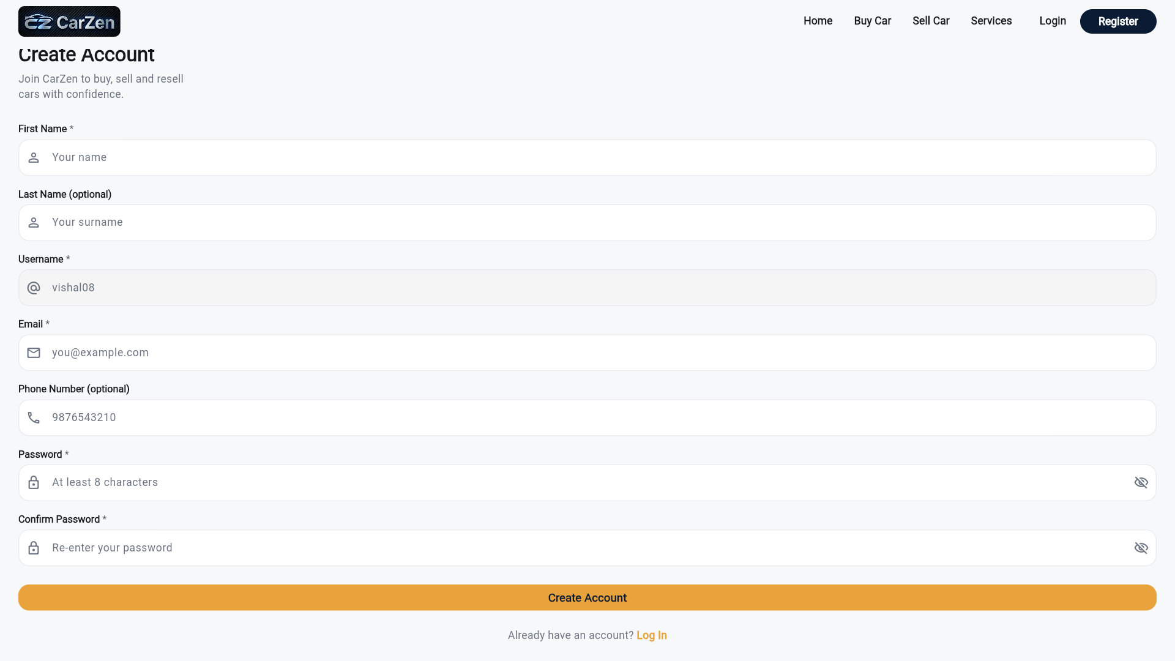

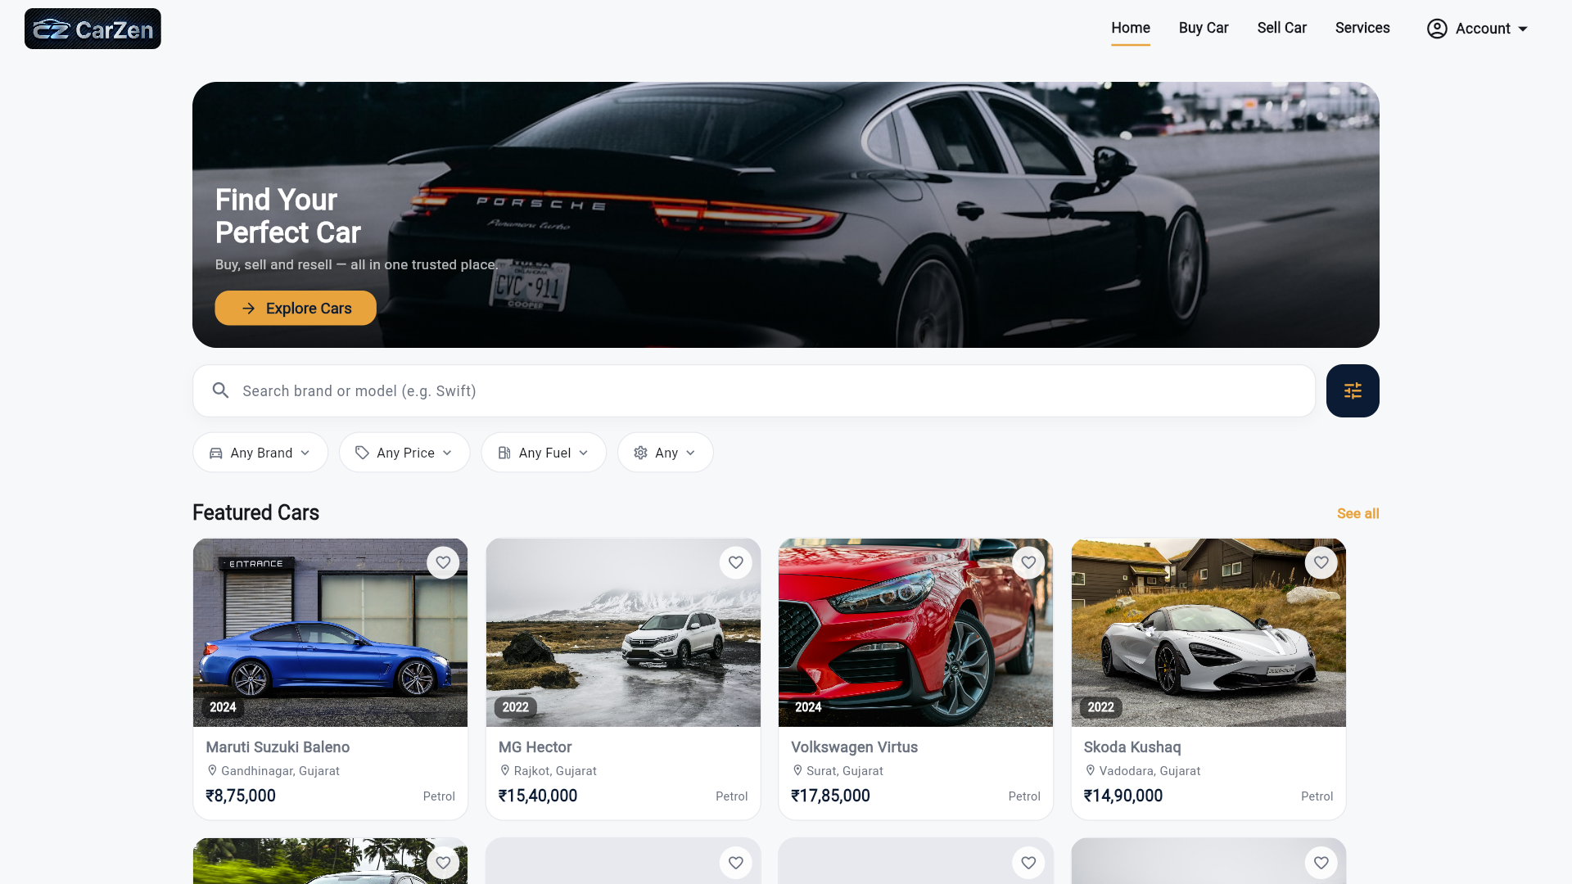
Home Page:

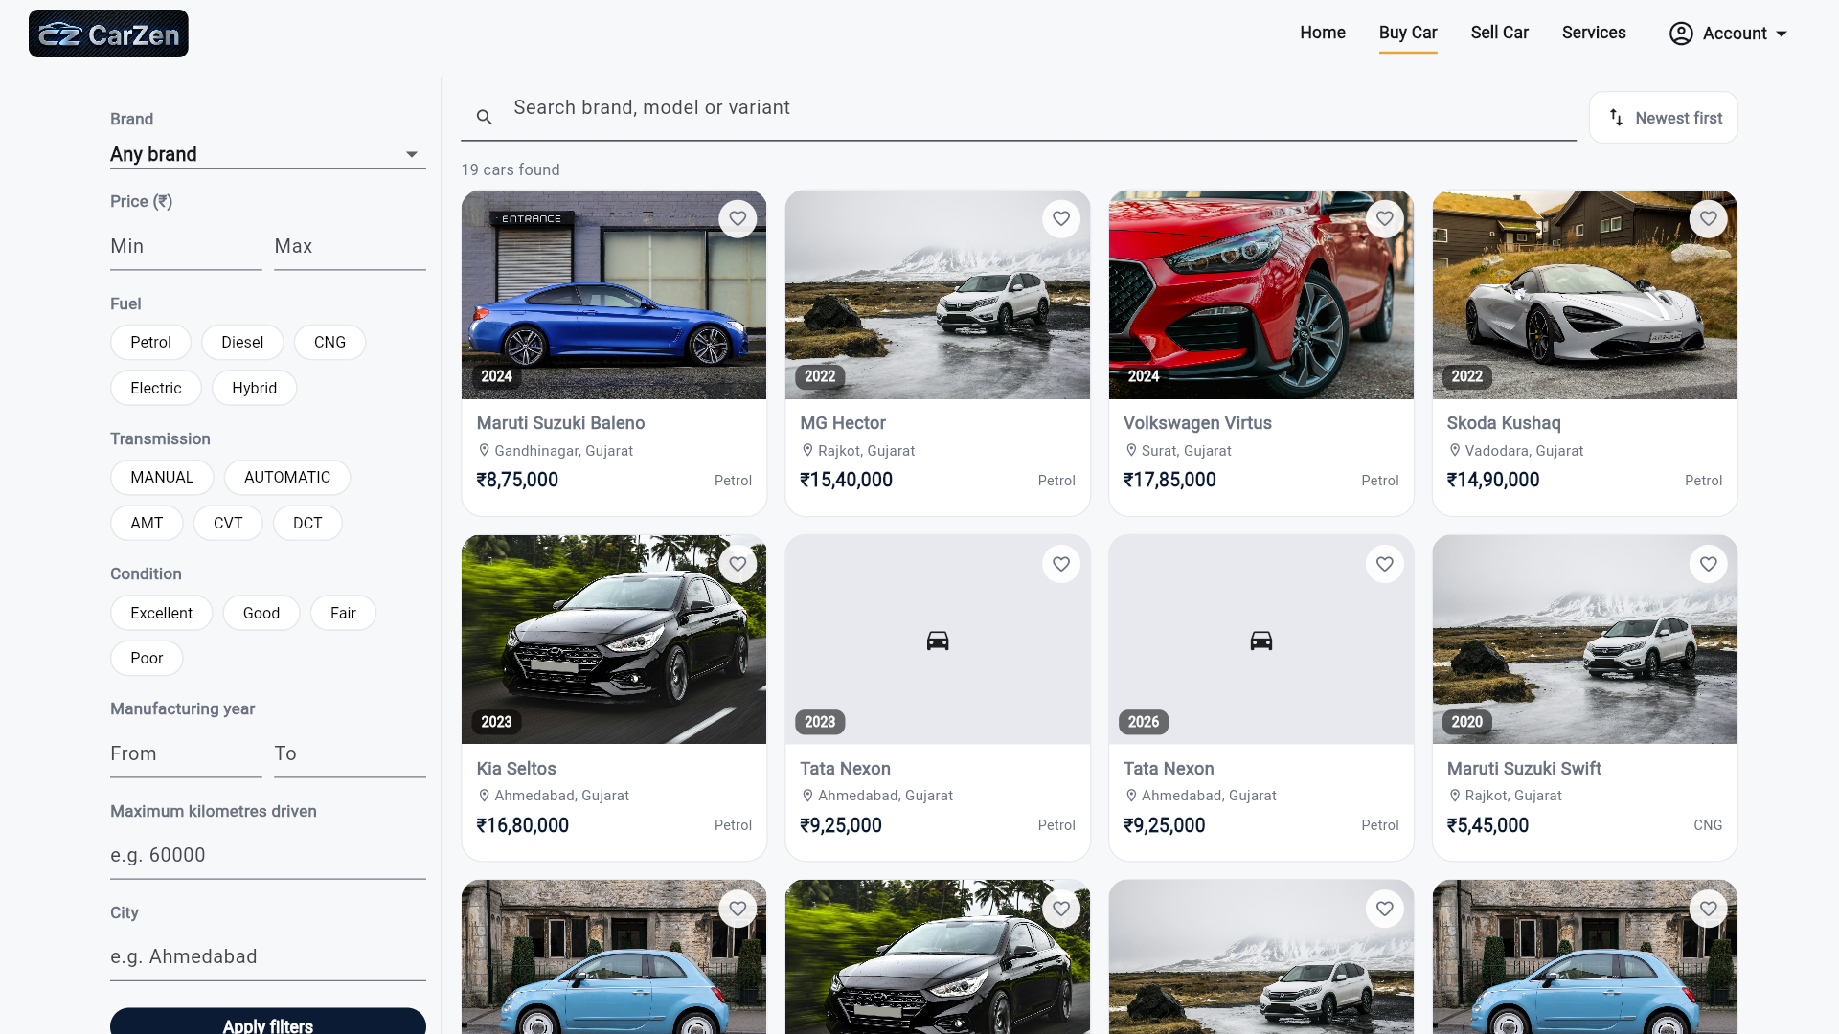
User Profile Page:
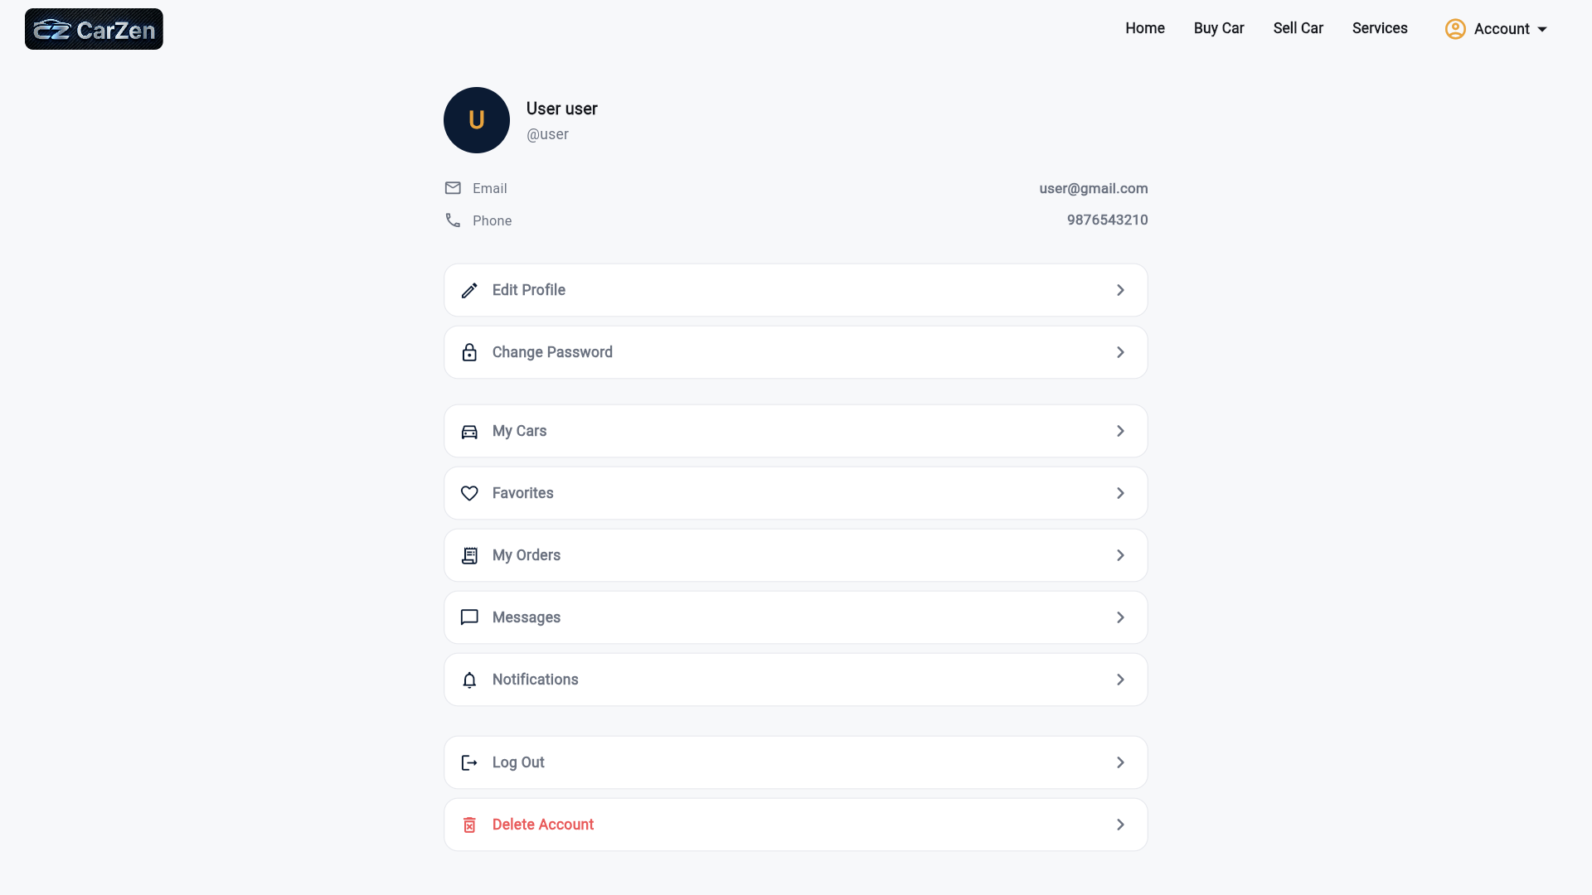

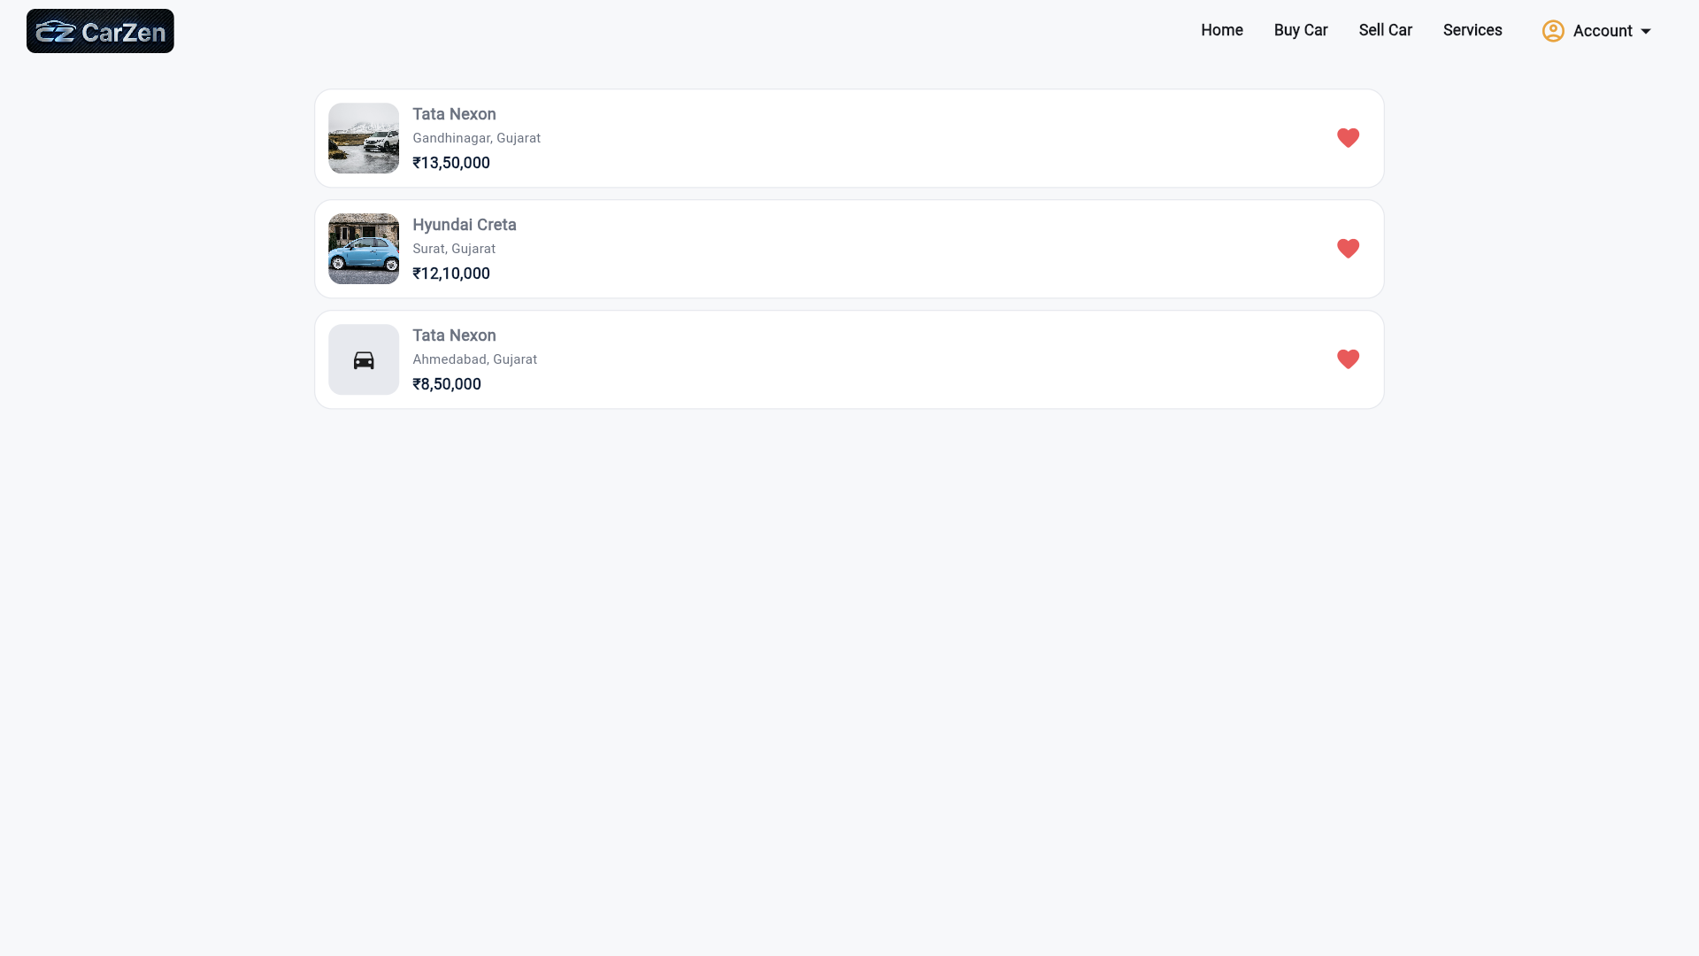

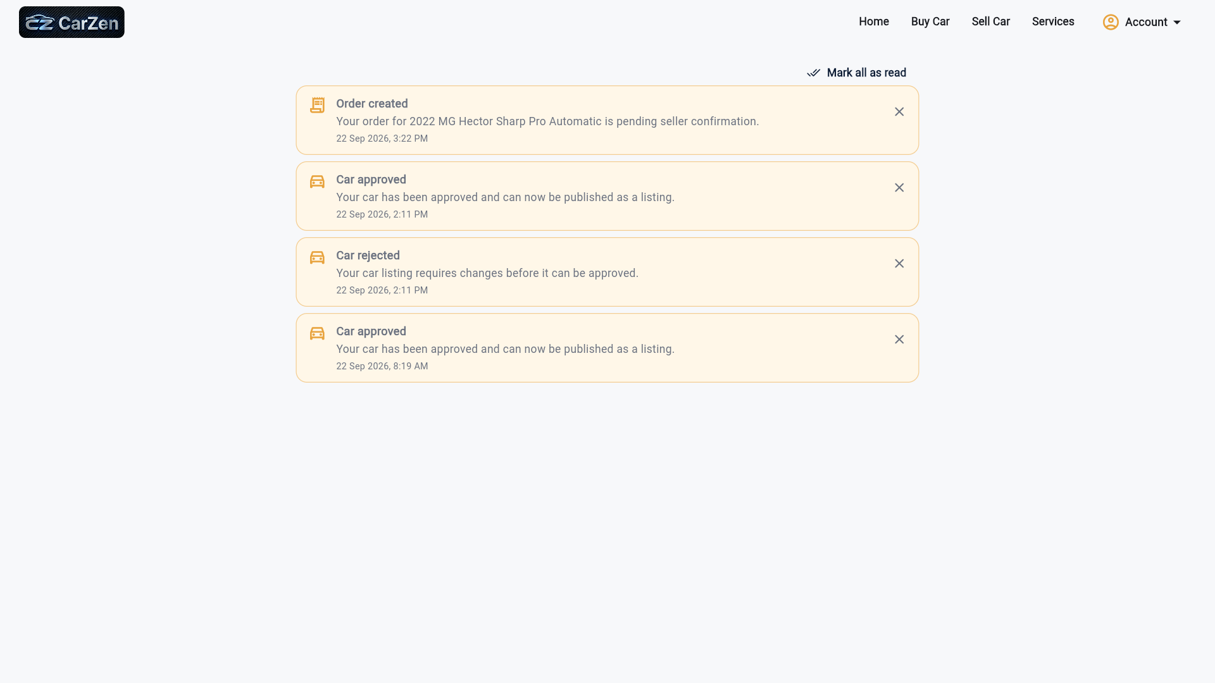

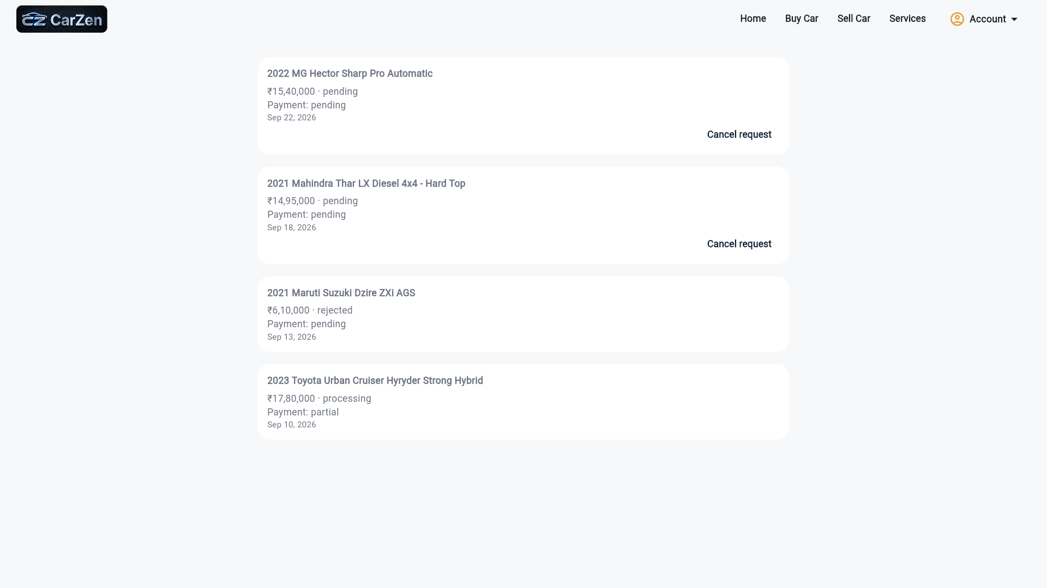

Admin Profile Page:
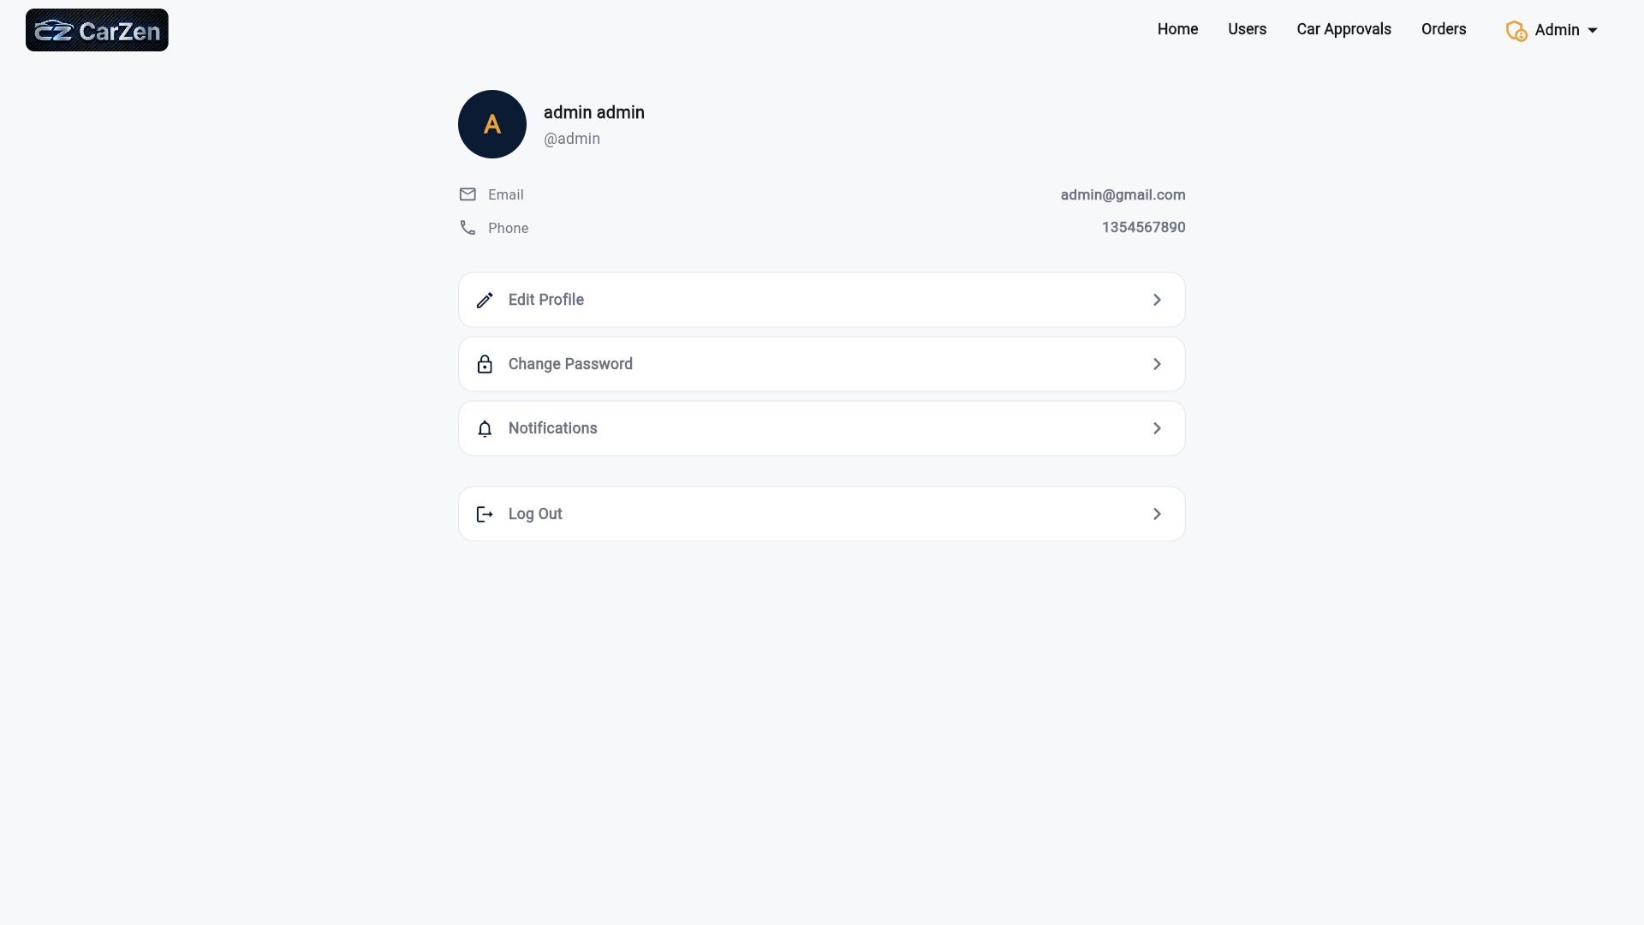

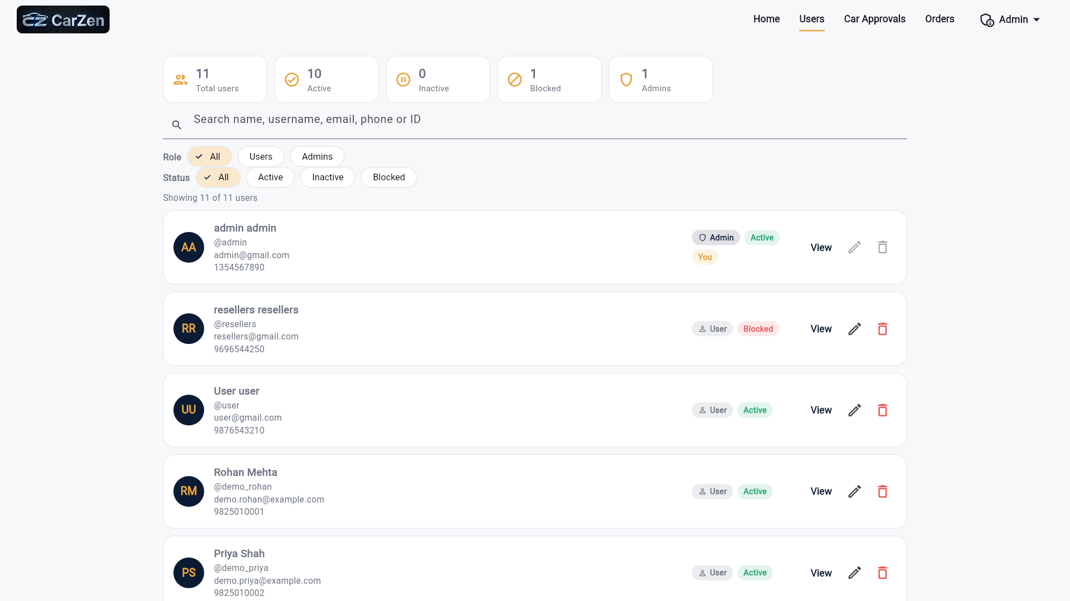

Order Details:
